AWS – LAMBDA TASKS

AWS Lambda Function Creation, Testing, and Public Access Configuration
Section | Details
Title | Creating, Testing, and Exposing an AWS Lambda Function Using Function URL
Objective | To create an AWS Lambda function, update and deploy its code, test the function using a custom test event, configure a public Function URL, and verify successful execution through browser access and CloudWatch logs.
Prerequisites | • AWS account with required permissions  • Access to AWS Management Console  • Basic understanding of AWS Lambda and Python  • IAM role with CloudWatch Logs permissions  • Web browser for testing Function URL
Steps Performed | • Created an AWS Lambda function from scratch  • Updated Python code and deployed changes  • Created and executed a test event  • Verified execution output and logs in CloudWatch  • Configured a Lambda Function URL with public access (Auth type: NONE)  • Invoked the Lambda function using the Function URL
Errors Faced | • Function URL was not accessible initially because it was not created  • No public endpoint available to invoke the Lambda function from a browser
How the Errors Were Fixed | • Created a Lambda Function URL from the Configuration tab  • Set authentication type to NONE to allow public access  • Used the automatically generated resource-based policy to permit invocation
Conclusion | The AWS Lambda function was successfully created, tested, and exposed using a public Function URL. The function executed correctly, returned the expected response, and generated logs in CloudWatch, confirming successful serverless deployment and invocation

Steps Performed
- Opened the AWS Management Console and navigated to AWS Lambda.
- Clicked on Functions in the Lambda dashboard.
- Selected Create function to start creating a new Lambda function.
- Chose the option Author from scratch as the function creation method.
- Entered a function name:
my-lambda-function.
- Selected the Runtime as Python 3.14.
- Chose the Architecture as x86_64.
- Kept the default Execution role, allowing Lambda to create a new role with basic permissions (including CloudWatch Logs access).
- Did not modify Additional configurations (left networking, security, and advanced settings as default).
- Clicked on Create function to deploy the Lambda function.
- After creation, the console navigated automatically to the Function overview page.
- Verified that the Lambda function my-lambda-function was successfully created and is visible in the function diagram.

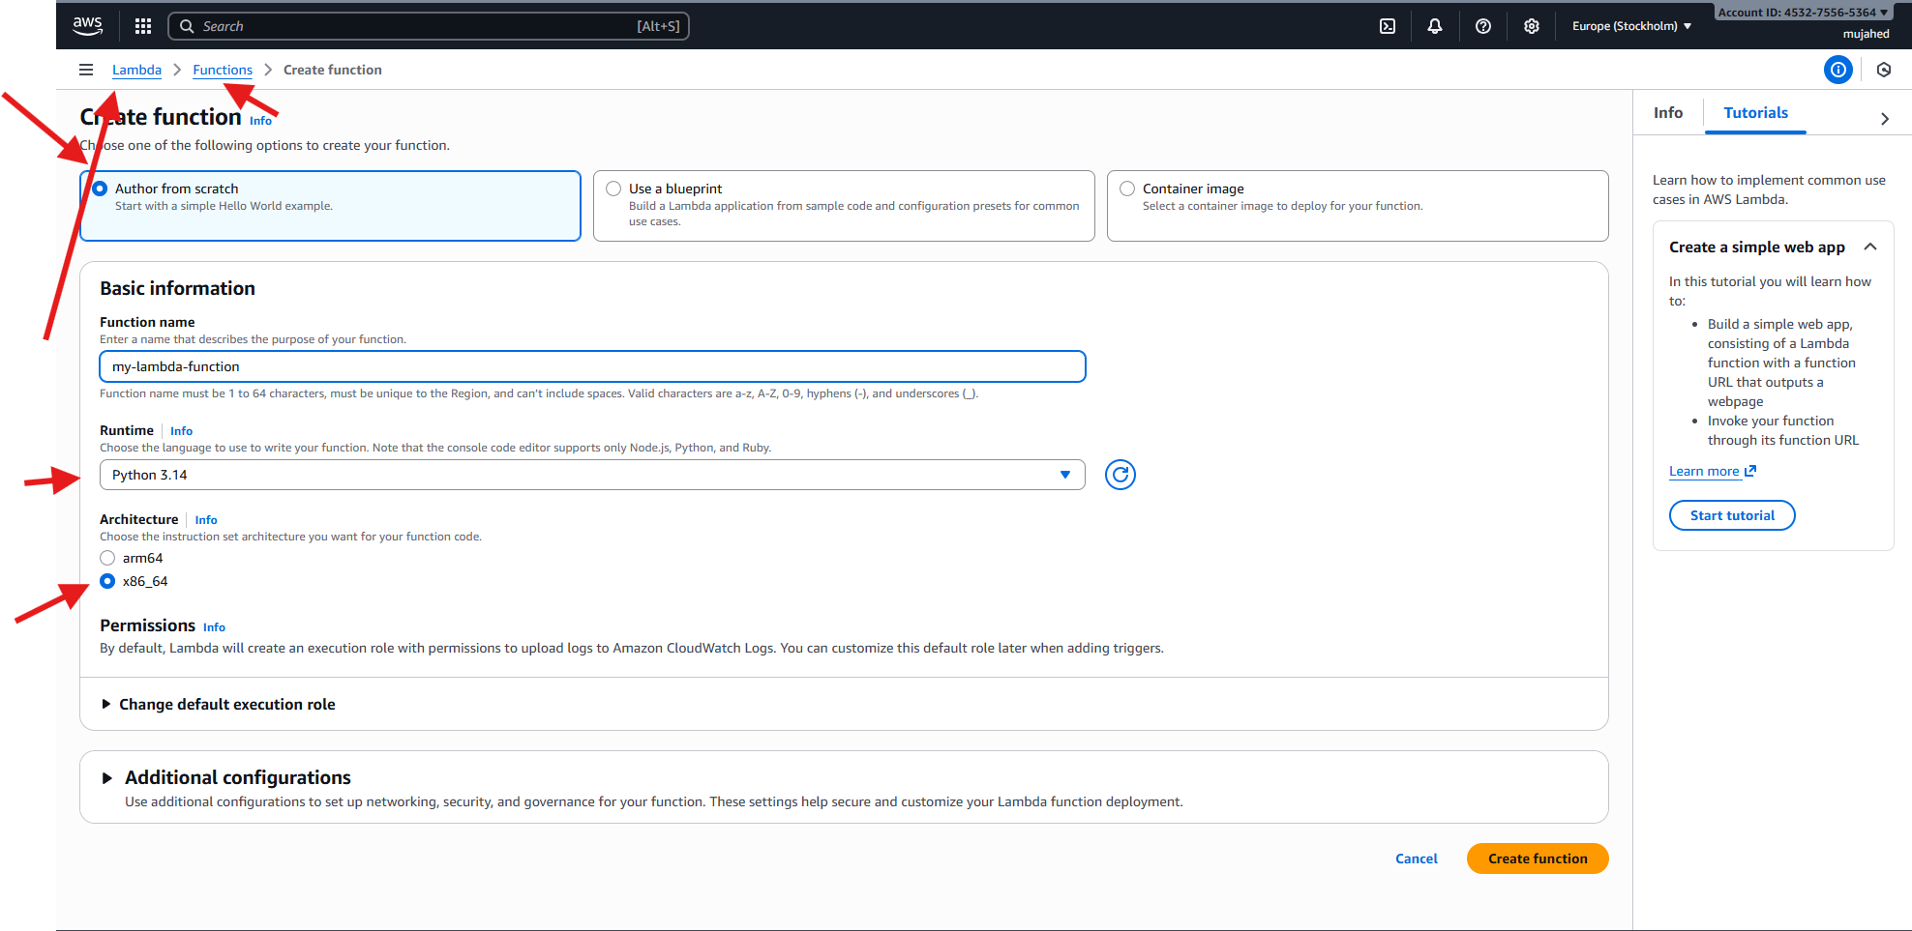

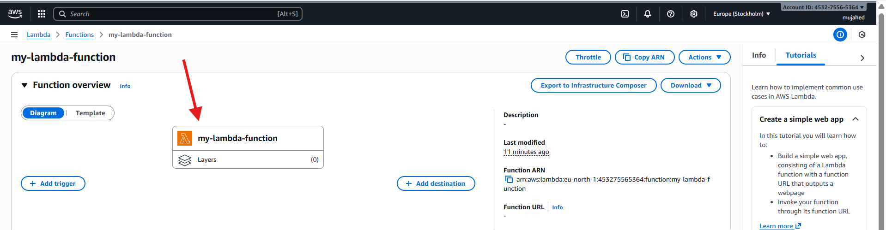

Steps Performed
- Opened the AWS Lambda console and selected the existing Lambda function.
- Clicked on Add trigger from the Lambda function page.
- Selected CloudWatch Logs as the trigger source.
- Chose the CloudWatch Log group associated with the Lambda function
(example: /aws/lambda/my-lambda-function or a specific log group path).
- Entered a Trigger name for identifying the CloudWatch Logs trigger.
- Left the Filter pattern optional field empty (or unchanged).
- Clicked on Add to attach the CloudWatch Logs trigger to the Lambda function.
- Navigated to the Amazon CloudWatch console.
- Opened Log groups under CloudWatch Logs.
- Verified the existence of the Lambda log groups, including:
  - /aws/lambda/my-lambda-function
  - Other related log groups (e.g., /vpc/flowlogs).
- Selected the Lambda log group to view log streams.
- Opened a log stream and reviewed log events, including:
  - START and END request entries
  - Execution duration and memory usage
  - Successful Lambda invocation logs
Confirmed that the Lambda function is generating logs and CloudWatch is capturing execution details correctly.
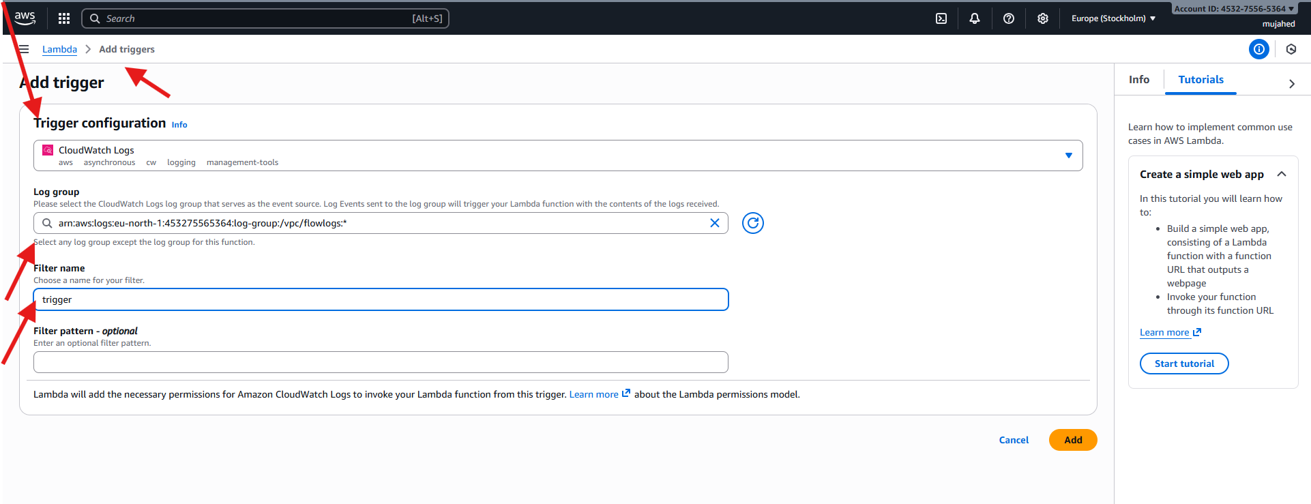

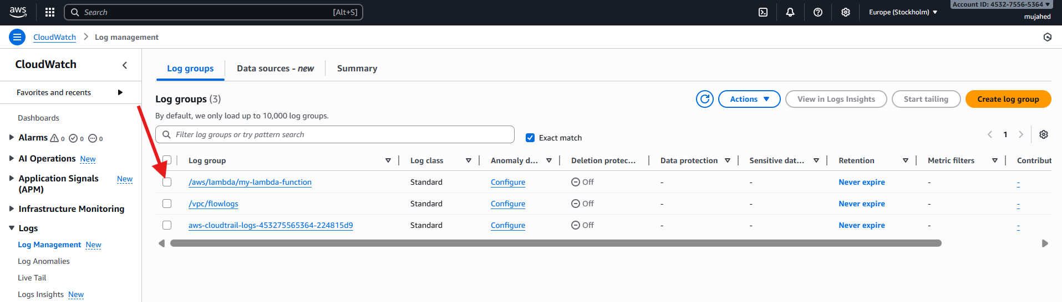

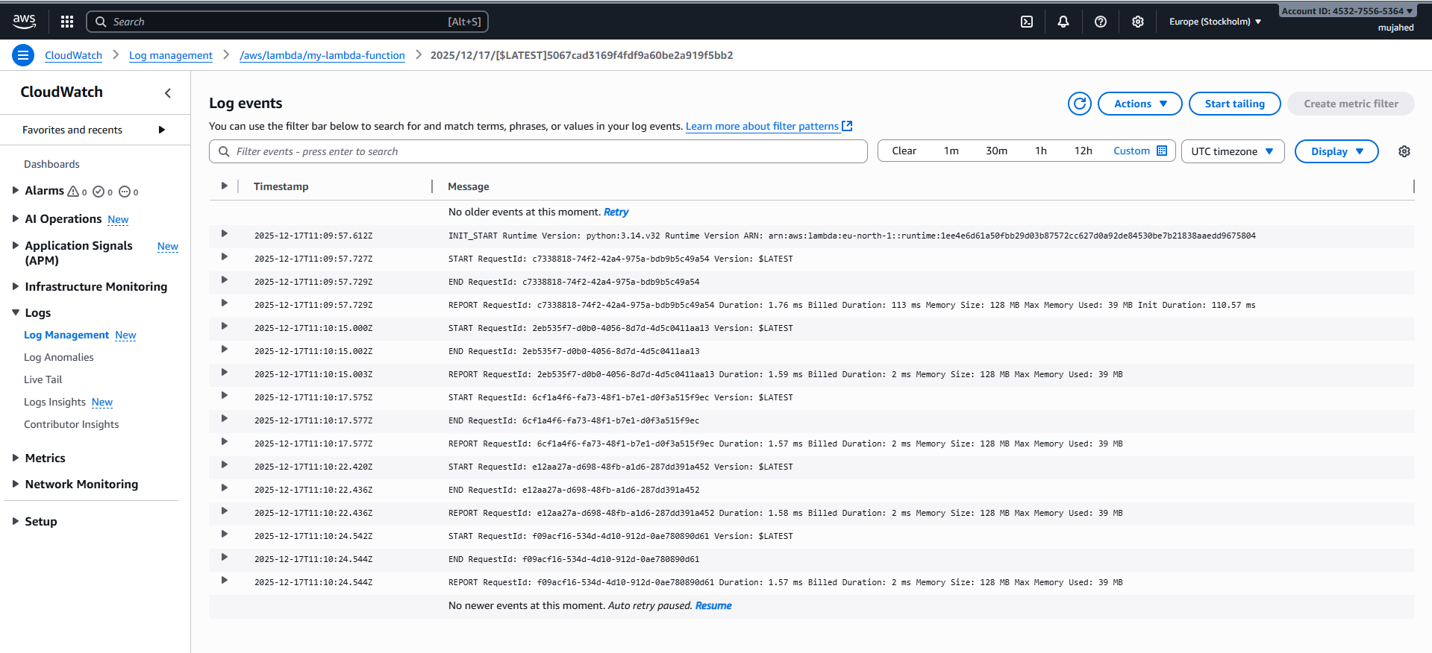

Steps Performed
- Opened the AWS Lambda console and selected the function my-lambda-function.
- Navigated to the Code tab of the Lambda function.
- Opened the lambda_function.py file in the inline code editor.
- Modified the Lambda handler code to print a message and return a JSON response:
  - Added a print() statement for log output.
  - Configured a 200 status code with a response body.
- Clicked Deploy to save and apply the code changes.
- Confirmed the successful deployment message at the top of the console.
- Clicked Test to execute the Lambda function.
- Selected Create new test event from the test event dropdown.
- Entered the test event name my_function_event.
- Chose Synchronous invocation type.
- Set Event sharing to Private.
- Selected the Hello World template for the test event.
- Left the default Event JSON unchanged.
- Clicked Save to create the test event.
- Clicked Test again to invoke the Lambda function using the newly created test event.
- Viewed the Execution results panel.
- Verified the response output showing:
  - StatusCode: 200
  - Response body: "Hello from Lambda!"
- Reviewed the logs output, including START, END, and REPORT entries.
- Confirmed successful execution, execution duration, and memory usage details.

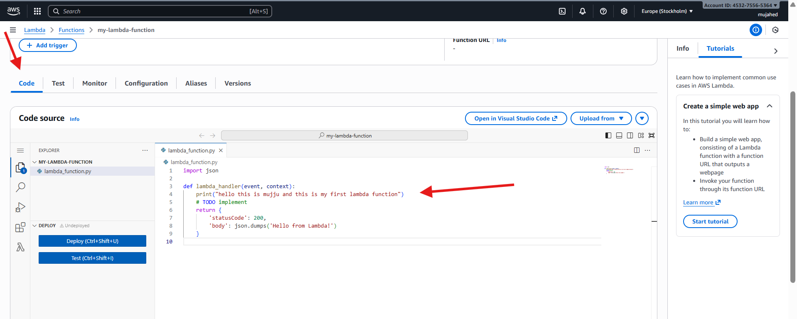

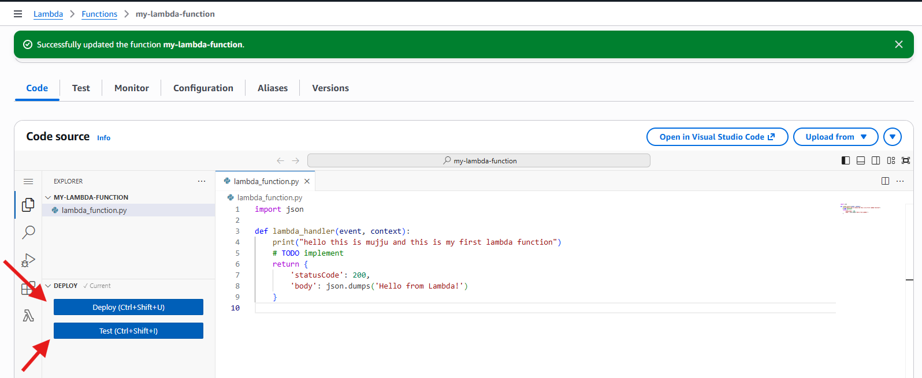

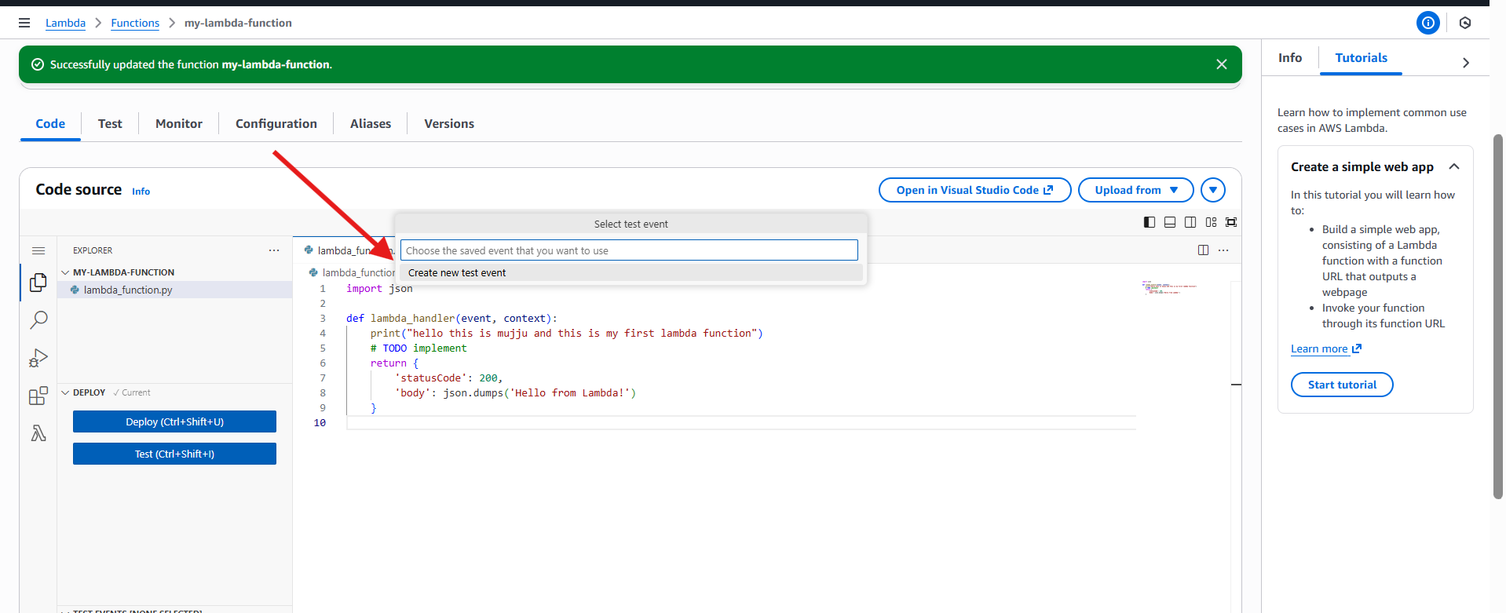

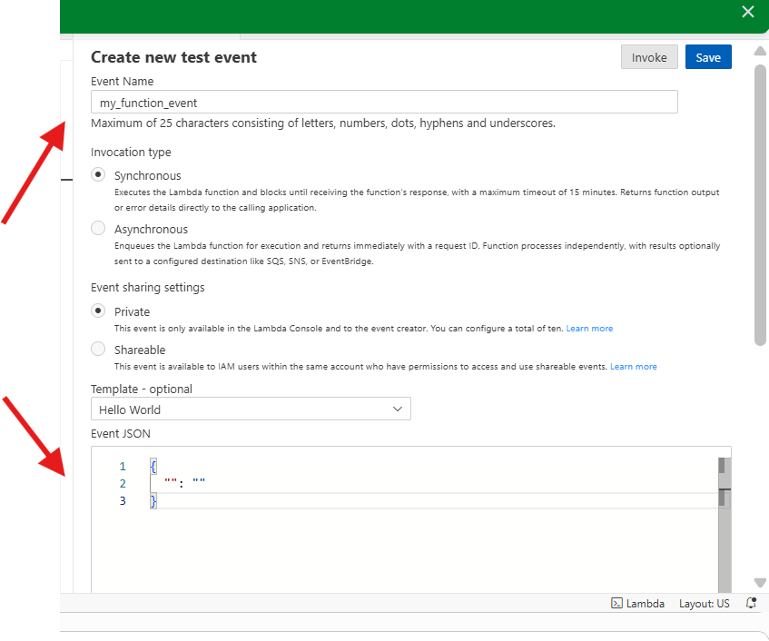

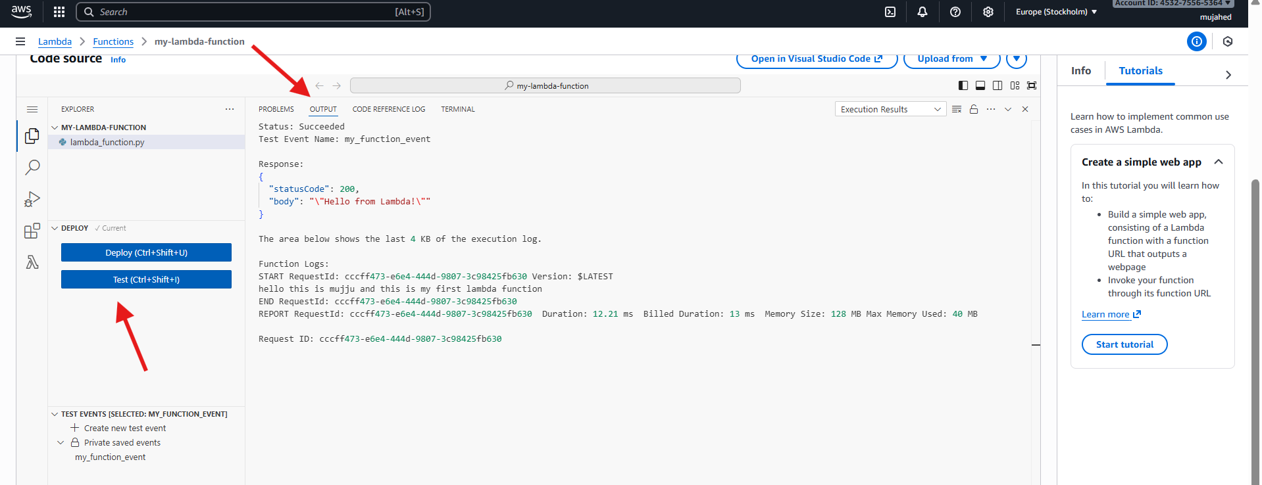

Steps Performed
- Opened the AWS Lambda console and selected the function my-lambda-function.
- Navigated to the Configuration tab of the Lambda function.
- Clicked on Function URL from the left-side configuration menu.
- Clicked Create function URL.
- Selected Auth type: NONE to allow public access to the Lambda function.
- Reviewed the automatically generated resource-based policy that allows public invocation of the function URL.
- Proceeded with the default settings and created the Function URL.
- Verified that the Function URL was successfully created and marked as public.
- Copied the generated Lambda Function URL.
- Opened a web browser and accessed the Lambda Function URL.
- Observed the function response displayed in the browser:
“Hello from Lambda!”
- Confirmed that the Lambda function was successfully invoked via the Function URL without authentication.

